**Cave Escape**

**Summary**

**Escape the cave but watch out for enemies and obstacles on the way.**

Players must attempt to escape the cave by finding the campfire at the end of the level. Players need to watch out for water and spikes as they traverse the level. There are enemies, if hit, the player loses a level. Shoot arrows at enemies to eliminate them and gain points. Points are also gained by collecting coins, every 1000 points earns the player an extra life.

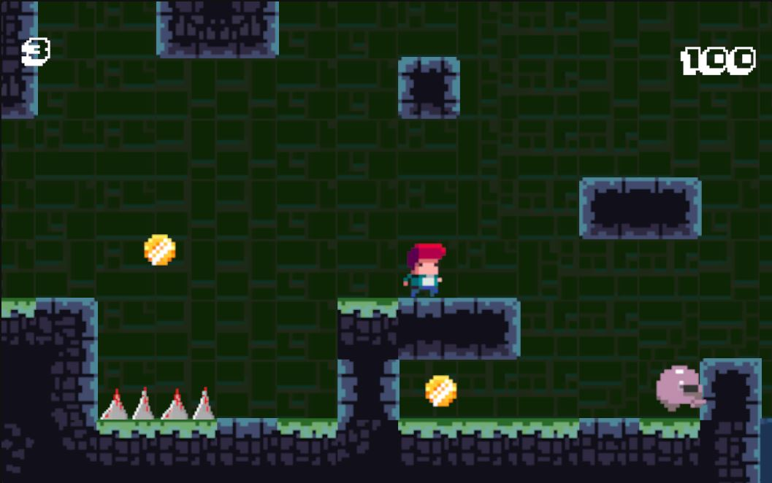

**Core**

The player needs to reach the end of the level where they find a campfire that will load the next level. There are enemies to shoot at, coins to collect, and mushrooms used to bounce higher to reach otherwise unreachable areas. As players collect more points, they can gain extra lives.

**Features**

Running, climbing, shooting, jumping.